**Natural Accommodation Lens**

The Journey From PAL to NAL®

1. History of Progressive Addition Lens −PAL
2. The PAL Evolution and It’s Current State
3. The Challenge
4. The New Natural Accommodation Lens −NAL Has Finally Arrived
5. NAL Timely Arrival and Its Impact on The Industry and The Patient

History of Progressive Addition Lens −PAL

The first patent for a progressive lens was British Patent 15,735, granted to Own Aves with a 1907 priority date. However, this was unlike modern progressive lenses. It consisted of a conical back surface and a cylindrical front with opposing axes in order to create a power progression. Although Owen Aves’ design was never commercialized Essilor cannot technically be considered the creator of the first progressive lens. In 1948 Bernard Maitenaz followed in his father and grandfather's footsteps and joined *Société des Lunetiers*  as a research engineer. On March 2, 1951, Bernard Maitenaz deposited an envelope at the *National Institute of Industrial Property* in France which included four drawings and mechanical data that would make it possible to manufacture the modern-day progressive lens. On November 25, 1953, *Essel* submitted the first patent on his invention.

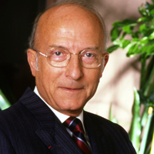The first commercially viable progressive lens in Europe, Essel’s Varilux, was introduced in 1959. In 1965 the Univis Omnifocal was introduced in the United States.  The first progressive lenses were made out of glass. In 1972 Essel name changed to ESSILOR because of the fusion of two companies Essel and Silor. In 1976 the first organic progressive lens Essilor’s version of Columbia Resin 39 (CR39) index 1.50 the Varilux Orma was released. A physicist Werner Koeppen and his team worked on the development of the Varilux Comfort from 1960 into the 1990ies and VARILUX became the most successful PAL. Over half a century has passed since the introduction of the PAL and the world has not been the same. Essilor has done an amazing job in the development, education, promotion and marketing of the progressive lenses and for sure deserves the biggest credit of all.

The PAL Evolution and It’s Current State

The advancements in equipment technology and software mathematical and development tools have opened the doors to an amazing new conceptual and design possibilities −the *Freeform* Revolution! First it was OptoTech’s founder Roland Mandler who in 1985 adapted aerospace industry CNC technology in the production of ophthalmic lenses. In 1986 Gunter Schneider of Schneider GmbH started to use the CNC technology in precision optics production and later evolved into ophthalmic lens production. However, the biggest game changer in PAL evolution came with the development of *PAL* *Freeform Lens Design Software*.

On October11, 1997 Japanese scientists Hiroyuki Mukalyama and Kazutoshi Kato filed patent application for Progressive Multifocal Lens and Manufacturing Method Of Eyeglass Lens And Progressive Multifocal Lens. The US 6,019,470 patent was granted on February 1, 2000, and was assigned to Seiko Epson Corporation. On July 18,

2000, the USPTO granted Patent for Spectacle lens with spherical front side and multifocal back side and process for its production, US6089713A, to Albrecht Hof and Aldabert Hanssen who assigned it to Carl Zeiss Vision GmbH. Both patents followed the conventional PAL concept but instead of utilizing semifinished lens with the progressive design casted or molded in the front side of the lens, the multifocal surface was created on the back of rotationally symmetrical front of the semifinished donor lens. In addition to the *PAL design on the back side of the lens* the final lens back surface was further modified for *Individual Optimization*. Over the past twenty something years that concept has radically improved the visual performance and acceptance of multifocal lenses and today, apart from ZEISS and SEIKO, there are numerous freeform lens design companies like IOT, Crossbows, Shamir, and Horizon, just to name a few. All freeform lens design companies are based on the conventional PAL utility: distance intermediate and near vision with around ±8mm progressive corridor. There are hundreds of various PAL designs and individual optimization nuances offering hundreds of “unique” or “proprietary” features. Because it is virtually impossible even for the most astute ECPs to study and assess them all, they are typically offering three types of PAL: GOOD, BETTER or BEST.

The Challenge

*The good, the bad and the ugly*

The good:

Yes, we are all well familiar with all the wonderful features and benefits of PAL lenses like:

• No line

• No image jump

• Distance intermediate, near vision

The bad:

We are all also well-aware of some of the less desirable features of the PAL like:

• Cumbersome navigation through short and narrow intermediate vision corridor

• Taking accurate and time-consuming fitting height measurements and frequent fitting height redos

• Spatial disorientation, nausea, or dizziness due to peripheral waviness and distortions

• Adaptation period

The ugly:

To be serious, there is nothing aesthetically *UGLY* about PAL; The Good, The Bad and The Ugly came from a funny movie that I enjoyed, 1966 epic spaghetti Western film directed by Sergio Leone, -remember?

The dream wish list:

It is over 60 years since the introduction of PAL, new knowledge and technological evolution in computer technology and advancements in software development toolswe have reached the point that realization of our dream wish list can be realized. First, we must drop our self-imposed limitations, get out of the box and start our quest armed with new knowledge, unaffected insight, creativity, commitment and courage. And the dream wish list? Actually, it is not that farfetched or long, thanks to the numerous PAL advancements we can enjoy today:

• NO ADAPTAION PERIOD or NON−ADAPTS should be required due to feelings of *swim or nausea*

• NO ADAPTATION PERIOD or NON−ADAPTS should be required due to *the learning process of navigation through short and narrow intermediate vision corridor*

• NO IRRITATING AND COSTLY REDOS should be required due to *inaccurate or incorrect fitting height measurements*

• FITTING HEIGHT MEASUREMENTS that are often complex and time consuming *should not be required*

Assembling the Development Team, Compiling Relevant and Timely Data, Gaining the Insight

Upon extensive deliberations and complex considerations, the decision was made, a multifocal lens that would meet the wish list criteria almost certainly can be developed. After nearly 5 years of blood, sweat and tears, a functional, commercially viable cloud based freeform digital lens design platform was developed.

That platform is perfectly suited to meet all our specialty and vocational lenses, bifocal and multifocal lenses, and all of our unconventional lens utility objectives and can be integrated with any lab management system. To gain new, untainted optical insight we studied large numbers of fitting height statistical data based on frame measurements, frame shapes and pantoscopic angles. We have created unconventional eye-lens ergonomic models and studied natural vision dynamics, natural vision habits, consulted with numerous ECPs, optical business experts and professionals and the Natural Accommodation Lens concept was born.

The New Natural Accommodation Lens −NAL® Has Finally Arrived

The dream lens concept is born: Natural Accommodation Lens (NAL®)

Michael Walach, the inventor, is the President of Quest Vision Care Specialty Lab and the CEO of QLDS, both located in Largo, Florida. On September 21,2021 the USPTO issued US Patent No.: US 11,126,012 B1 for Broadview Natural Addition Lens. On March 29, 2022, USPTO has granted second patent, US Patent No.: US 11,287,673 B1. NAL® and OMNILUX® are USPTO registered trademarks, registrant is Quest Vision Care Specialty Lab.

The NAL® does not have the short, awkward to navigate intermediate vision corridor inherent on PALs. NAL® has funnel shaped visual field comprised of substantially aspheric, lateral power bands that are vertically aligned along substantially vertical design backbone. The design backbone is mathematically created curvature based on actual natural downward gaze focal length deceleration requirements, on our unique eye/lens interaction ergonomic model, and extensive PAL fitting data.

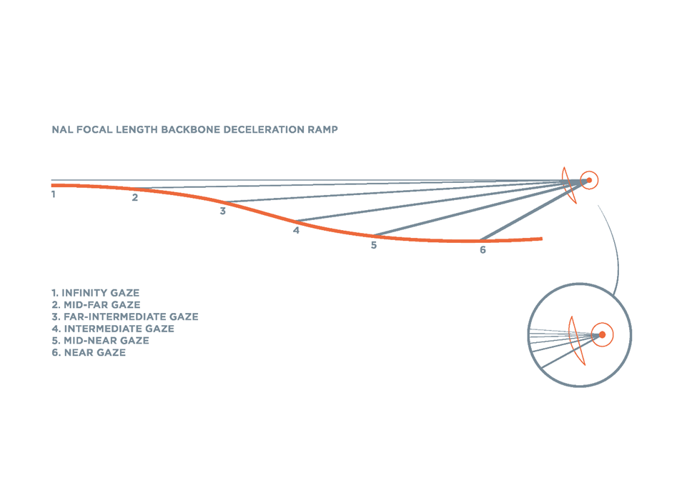The focal length deceleration curve addresses natural accommodation requirements for focal lens reduction *from 6 meters (20’) all the way to 25 cm (1’) along continuous smooth focal length deceleration ramp.*

• NO ADAPTAION PERIOD or NON−ADAPTS due *to feelings of* *swim or nausea*;

The new NAL® peripheral swim effect was eliminated and substituted with peripheral defocus therefor eliminating the swim effect inherent on all

PALs. We have been able to achieve that effect by:

• The application of substantially lateral aspheric broad power bends aligned vertically along NAL® backbone and interpolated by various bi-quadratic, cubic, and quintic polynomials and splines into one smooth continuous surface

• Complex digital ironing across out of visual field peripheral areas

• Significant reduction in focal length deceleration rate along the substantially vertical NAL® principal design axis due to 2 to 4 times longer add power acceleration ramp radically reduces unwanted lateral astigmatism as per Minkwitz Theorem.

• NO ADAPTAION PERIOD or NON−ADAPTS *due to* *the learning process of navigation through short and narrow intermediate vision corridor.* Because the NAL® visual field is funnel shaped there is no short and narrow progressive corridor to learn to navigate through. NAL® *adaptation is virtually instant and the navigation is instinctive and natural.*

• NO IRRITATING AND COSTLY REDOS due to *inaccurate or incorrect fitting height measurements*

• The NAL® visual field is funnel or martini glass shaped therefore it does not have short and narrow intermediate vision corridor like PAL; *NO progressive corridor NO FITTING HEIGHT* time consuming measurements required *NO incorrect FITTING HEIGHT issues and irritating redos*. Just gently lower or raise your chin your gaze fixed on the viewed object to perfectly focus at the required distance. The objective of the NAL® concept is to provide a youthful natural single vision viewing experience for active and professional presbyopes. Numerous wearer studies proved that that is the factual viewing experience. Remember youthful vision? Perfect for office, golf, bike, tennis, computer; you name it.

NAL Timely Arrival and Its Impact on The Industry and The Patient

It appears that despite enduring efforts of lens designers around the world the bell curve of new PAL concept design innovations is significantly leveling off. There have been over 60 years of PAL design improvements and design modifications. Since SEIKO, ZEISS and RODENSTOCK pioneered the backside lens surface individual optimization concept over 20 years ago there have been over 200 “proprietary” or *patented designs* introduced since the digital freeform revolution. New PAL innovation at this time appears like trying to squeeze water from the stone.

The consequence of that is that there is, to no surprise, considerable disorientation among the global ECP community as to actual and objective visual performance of the numerous PAL design offers. Most understand that with todays freeform digital technology it's more about branding and marketing. Most commonly it is GOOD, BETTER, or BEST PAL by major corporate brands and various private labels. The same PAL concept, different day.

It is also important to realize, whether you accept it or not, that the Prescription Eyewear e-commerce business is growing about 10 times faster than brick and mortar. It seems reasonable to assume that the trend is going to continue. The ECP brick and mortar community should give serious consideration and expand their marketing outreach via an e-commerce presence. At this moment multifocal PAL internet sales are falling far behind the brick and mortar PAL sales but with the NAL® no fitting height utility that ratio might significantly alter the numbers in favor of e-commerce.

NAL is available as OMNILUX for all daily youthful vision needs, OMNILUX OFFICE for extensive computer work, and advanced version OMNILUX PRO for brick and mortar ECP practices where the fitting height measurement is required. That data is utilized to further refine the vertical position of the NAL design to facilitate for best optical performance and visual comfort for atypical frame shapes and unusual or special fitting requirements. NAL® is available in all lens materials and treatments. The Rx power range is +8.00 D to -12.00 D SPH, -5.00 D CYL, PRIZM up to 5.0 D. The ranges can vary, wider or narrower depending on type of freeform production line, lens material and LDS provider.

For more information, ECP product availability or freeform capability labs globally to secure LDS license contact:

QLDS, Inc.

9161 132nd Ave N

Largo, FL 33773

Robin Cassidy

President

(503) 720.9836

robin.cassidy@qldsamerica.com

www.qlds.eu

QUEST VISION CARS SPECIALTY LAB,

9130 132nd Ave N

Largo, FL 33773

Michael Walach

(717)581-4100

[mwalach1@gmail.com](mailto:mwalach1@gmail.com)

www.questopticallab.com